# The Align Menu

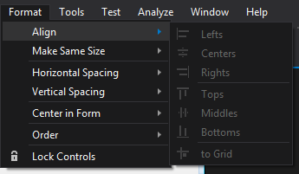

The Align menu (within the Format menu) is a simple way to align multiple UI elements at once. While the drag and drop alignment works while placing one element at a time, it can be quicker to just place multiple UI elements, select them all and then choose the method you would like to align them by.